***… where the IMI/isolates come from?***

* Briefly describe field trial
  + A longitudinal, cross-sectional study of 10 certified organic dairy farms in VT was carried out in Winter 2019-2020. Although the original intention was to complete 4 farm visits 4 weeks apart for each herd, most (8) herds were only sampled 3 times before the field study was interrupted by the COVID-19 pandemic. Four farm visits were able to be completed at one herd before interruption. One herd milks seasonally; two visits were completed before animals were dried off for the winter, but plans to come back and finish sampling when they freshened again were foiled by the pandemic. Thirty lactating cows of varying parity in early- to mid-lactation were chosen at random to be repeatedly sampled for the duration of the study. If a cow was dried off or left the herd during the study, she was replaced with another lactating cow in the herd which was dictated by convenience. At each farm visit, duplicate quarter milk samples were aseptically collected from each lactating quarter immediately before milking for all enrolled cows.

*Herd description*

On average, farms milked about 58 cows, with a variety of breeds represented. There were 5 farms using a tiestall facility, and 5 farms where cows were housed on a bedded pack.

Certified organic dairies in Vermont (unless I said this already)

What else we need for herd description?

*Description of data frame, structure*

Started with 3331 observations where the intramammary infection status of a quarter could be determined; quarters were then selected that had an intramammary infection due to any “frequently observed” *Staphylococcus* species (species with ≥ 5 associated observations; n = 761), as well as all quarters that were culture negative (n = 2290). Quarters collected from cows > 305 days in milk at time of observation were then discluded (n = 266), as well as any missing associated DIM information (n = 6). Any quarters missing an associated somatic cell count (n = 104) were then discluded, leaving 2,675 quarters with a valid SCC measurement that were culture negative or had an intramammary infection due to frequently-found *Staph.* species. Lastly, 55 observations were omitted where a quarter had an intramammary infection due to more than one pathogen (mixed infection). This left 2,620 complete observations from cows ≤ 305 days in milk at time of sample collection, where a quarter either had an intramammary infection due to a frequently-found *Staphylococcus* species in pure culture or was culture negative (Table XX). [Maybe this is better as a flowchart – just depends on number of figures we want to have.]

This can be moved to methods-

* Aerobic culture
  + Standard aerobic bacteriological culture of milk samples was performed in duplicate to identify IMI ?within 24 hours of collection?
  + A quarter was considered positive for an IMI when greater than or equal to 1 CFU was identified with the same morphology for both duplicate samples, and negative when there was no significant growth in that quarter on either duplicate plate.
  + plated 10 uL milk; would be equivalent to 100 CFU/mL
    - can reference Dohoo saying we sacrificed sensitivity for NASM IMI ID here, but with high-ish contamination rate (collecting large number of samples in the field with minimally trained help occasionally, under time pressure), wanted to trade-off for specificity
* Flow cytometry at State Lab for qSCC
  + an aliquot was sent to the state agricultural lab for quarter-level somatic cell count using flow cytometry (Somacount FC, Bentley).
  + these were off frozen samples
* MALDI for identification (speciation of Staphylococcal isolates from IMI)
  + Bacteria deemed to be causing IMI were first presumptively identified based on morphology, hemolytic pattern, and standard bench-top diagnostic methods (catalase, gram-stain, coagulase for hemolytic gram-positive, catalase-positive isolates, or any that were highly suspicious for *Staph. aureus*)
  + All isolates collected were then sent for identification to the species level using MALDI-ToF (Dr. Pamela Adkins, U. Missouri).
* DHIA and records data
  + DIM and parity were obtained from DHIA records for 9/10 herds
  + DIM and parity for last herd was obtained from producer who kept meticulous written records

***Data analysis:***

Data analysis was carried out using the R Statistical Programming Environment.

Somatic cell counts associated with quarters identified to have single-pathogen intramammary infections with a given Staphylococcal species were compared with the SCC of all culture negative quarters. Quarters that had an intramammary infection due to more than one pathogen (mixed infection) were discluded from analyses. Raw quarter-level somatic cell count was converted to somatic cell score [log2(raw quarter somatic cell count/1000) + 3] in order to address the non-normal distribution of of SCC data.

A linear mixed-effects model was fitted to the data set in order to explore the effect of different Staphylococcal species on quarter SCC, using the “lme” function of the “nlme” package (R Statistical Programming Environment, R Core Team, 2024). In this model, the somatic cell score for each quarter observation was the outcome variable, and Staphylococcal species causing IMI (with culture negative quarters as the reference value) was the fixed predictor variable. The number of days in milk at time of sampling was included in the fixed part of the model to adjust the estimates of the Staph. species and quarter SCC association for confounding by this variable. The hierarchical structure of the data was addressed by fitting random intercepts for quarter, cow, and herd (observations nested within quarter, quarters nested within cow, and cow within herd). Samples collected at different time points for a given quarter were considered repeated measurements, and a spatial exponential correlation structure was used to account for the correlation between multiple milk samples collected from the same quarter. Best way to say we are essentially ignoring the time between observations (~30 days), as it’s so short?

Actually put model in:

IMI and DIM (as a 3 degrees polynomial term)

SCS*ijkl* = β0 + β1 Staph. species*ijkl* + β2DIM*ijkl* + β3DIM*ijkl*2 + β4DIM*ijkl*3 + v*l* + u*kl* + w*jkl* + e*ijkl*,

where SCS*ijkl* is the predicted somatic cell score for the *i*th sample of the *j*th quarter of the *k*th cow from the *l*th herd; β0 is the intercept; β1, β2, β3, and β4 are the regression coefficients for Staphylococcal species, DIM (centered on 200 DIM- don’t think we did this), DIM quadratic and cubic terms (to correct for the nonlinear relationship between DIM and SCS), respectively; and *vl*, *ukl*, *wjkl*, and *eijkl*are the herd random effect, cow random effect, quarter repeated effect, and sample error term, respectively (approximate normal distribution assumed).

* Linear mixed-effects model fit by REML (restricted maximum likelihood)
  + Random effects:
    - quarter within cow within herd
  + Fixed effects:
    - Third-degree polynomial with DIM
    - IMI status (no growth, staph. by species)
    - Interaction terms between IMI and DIM were not significant (P-value = 0.42). So, both IMI status and DIM affect SCS, but the effect of IMI status on SCS does not vary as function of DIM
  + Correlation structure:
    - spatial exponential correlation structure

***Results:***

The final data set of 2,260 observations came from 1,272 quarters of 360 cows across the 10 herds included in the field study. The mean (median; range) number of cows included per herd was 36 (36; 34-39), whereas the number of quarters sampled per cow was 3.5 (2; 1-4). The mean number of observations per quarter included was 2.1 (2; 1-4).

Num quarters, cows, herds, observations per cow, per quarter (range and mean)

Average and range of time between sequential observations

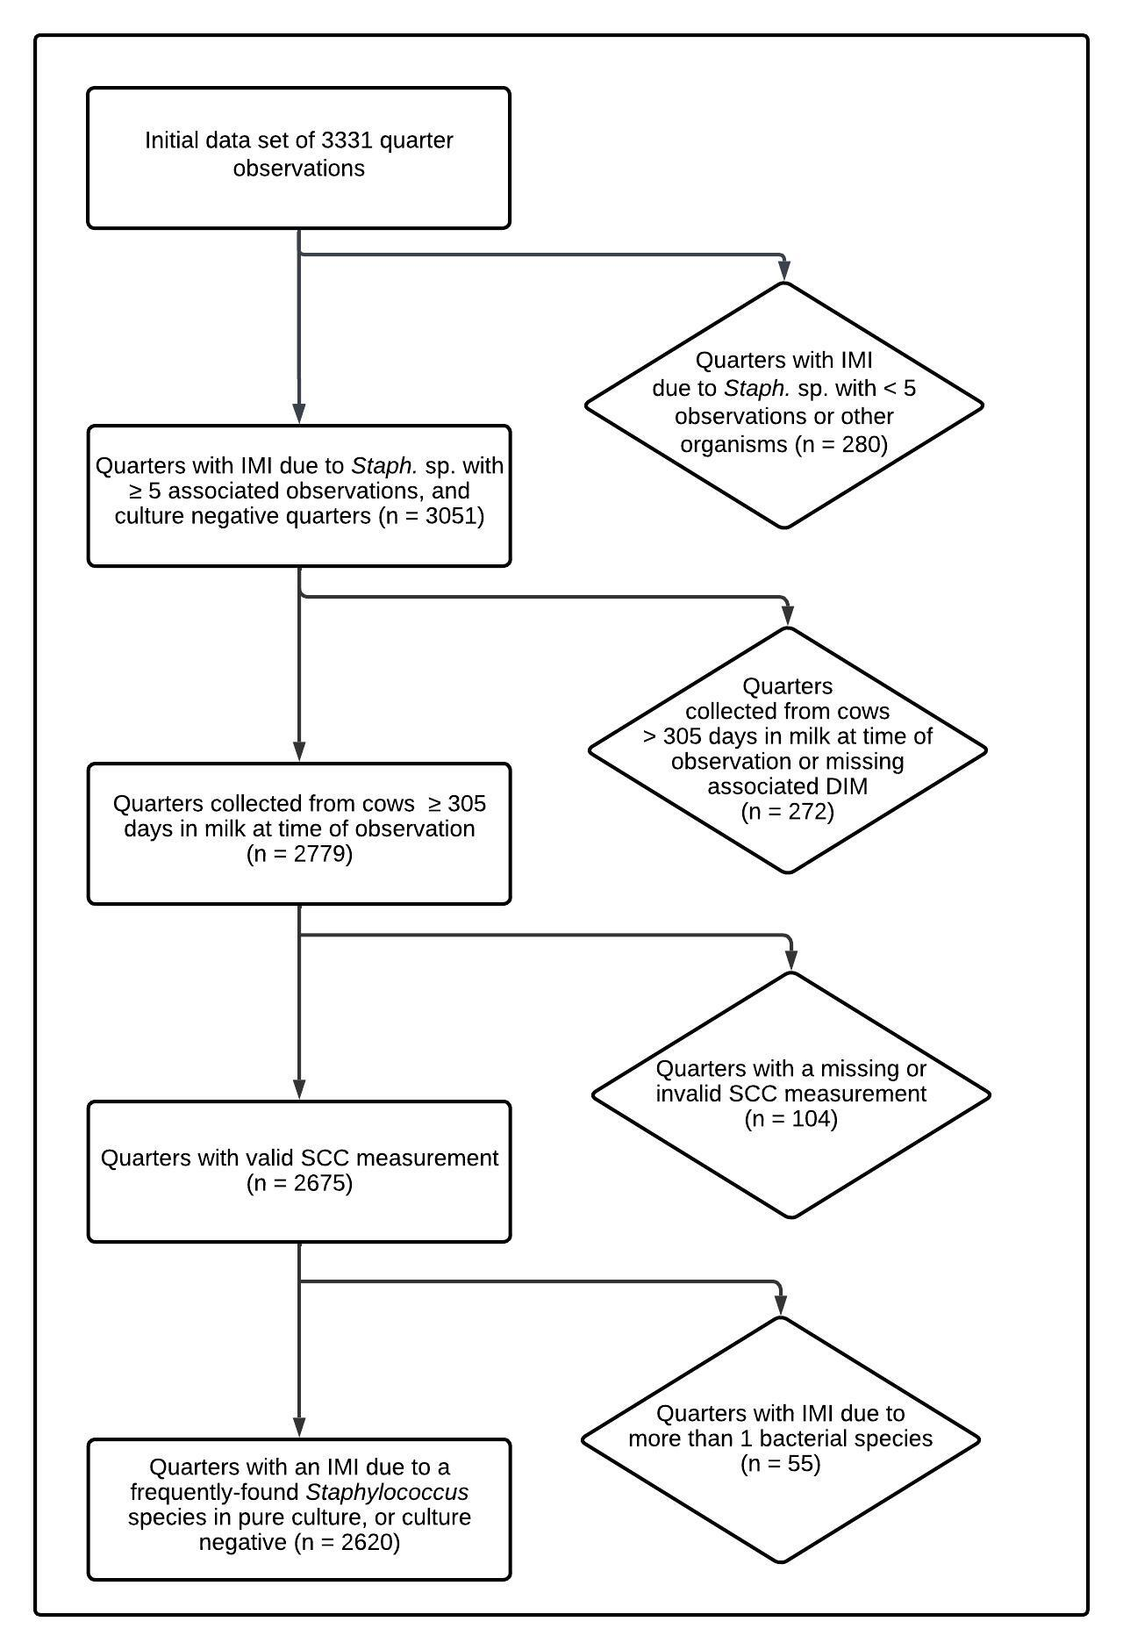

Figure XX.Flow diagram describing selection of final data set.

|  |  |  |  |
| --- | --- | --- | --- |
| Table XX. Final multivariable model describing the effect of intramammary infection with frequently-isolated *Staphylococcus* species on quarter somatic cell score, adjusted for days in milk at time of sampling. [Do I need to mention that DIM was included as a 3-degree polynomial term/If yes, how share this? Do all three levels of DIM coefficient and SE go into the table as well? Some of the p-values are crazy tiny – how far out with 0’s should we go? Do I need the asterisks?] | | | |
| *Staphylococcus* sp. | No. quarter observations | Coefficient estimate (SE) | *P*-value |
| Intercept | - | -0.03 (0.29) | 0.90 |
| No growth | 1972 | *Reference* | *Reference* |
| *S. agnetis* | 21 | 3.76 (0.45) | <0.00001* |
| *S. aureus* | 112 | 4.81 (0.22) | <0.00001* |
| *S. chromogenes* | 384 | 2.88 (0.12) | <0.00001* |
| *S. devriesei* | 15 | 1.62 (0.54) | 0.003* |
| *S. equorum* | 9 | 0.12 (0.48) | 0.81 |
| *S. haemolyticus* | 40 | 1.77 (0.31) | <0.00001* |
| *S. hyicus* | 6 | 3.23 (0.85) | 0.0001* |
| *S. simulans* | 35 | 3.11 (0.39) | <0.00001* |
| *S. warneri* | 15 | 5.18 (0.60) | <0.00001* |
| *S. xylosus* | 11 | 2.96 (0.62) | <0.00001* |
| Days in milk (1) | - | -0.003 (0.01) | 0.54 |
| Days in milk (2) | - | 0.00001 (0.00004) | 0.73 |
| Days in milk (3) | - | <0.00001 (<0.00001) | 0.53 |
| * Quarter somatic cell score differs from negative controls | | | |

|  |  |  |
| --- | --- | --- |
| Table XX. Estimated quarter somatic cell count by intramammary infection status at 91 days in milk (13 weeks) for frequently-isolated *Staphylococcus* species and culture-negative quarters. [which one we like better?] | | |
| *Staphylococcus* sp. | Estimated quarter somatic cell count (cells/mL) | 95% lower and upper confidence level (cells/mL) |
| No growth | 10,927 | 8,056 - 14,822 |
| *S. agnetis* | 148,437 | 69,021 - 319,232 |
| *S. aureus* | 307,101 | 197,323 - 477,951 |
| *S. chromogenes* | 80,376 | 56,942 - 113,454 |
| *S. devriesei* | 33,513 | 13,597 - 82,599 |
| *S. equorum* | 11,855 | 5,292 - 26,556 |
| *S. haemolyticus* | 37,333 | 21,217 - 65,688 |
| *S. hyicus* | 102,478 | 26,368 - 398,281 |
| *S. simulans* | 94,617 | 48,346 - 185,175 |
| *S. warneri* | 395,190 | 148,189 - 1,053,891 |
| *S. xylosus* | 84,985 | 30,798 - 234,512 |

|  |  |  |  |
| --- | --- | --- | --- |
| Table XX. Estimated raw quarter somatic cell count by intramammary infection status at 91 days in milk (13 weeks) for frequently-isolated *Staphylococcus* species and culture-negative quarters. [which one we like better?] | | | |
| *Staphylococcus* sp. | Estimated quarter somatic cell count (× 1,000 cells/mL) | 95% lower confidence level (× 1,000 cells/mL) | 95% upper confidence level (× 1,000 cells/mL) |
| No growth | 10.9 | 8.1 | 14.8 |
| *S. agnetis* | 148.4 | 69 | 319.2 |
| *S. aureus* | 307.1 | 197.3 | 478 |
| *S. chromogenes* | 80.4 | 56.9 | 113.5 |
| *S. devriesei* | 33.5 | 13.6 | 82.6 |
| *S. equorum* | 11.9 | 5.3 | 26.6 |
| *S. haemolyticus* | 37.3 | 21.2 | 65.7 |
| *S. hyicus* | 102.5 | 26.4 | 398.3 |
| *S. simulans* | 94.6 | 48.3 | 185.2 |
| *S. warneri* | 395.2 | 148.2 | 1,053.9 |
| *S. xylosus* | 85 | 30.8 | 234.5 |

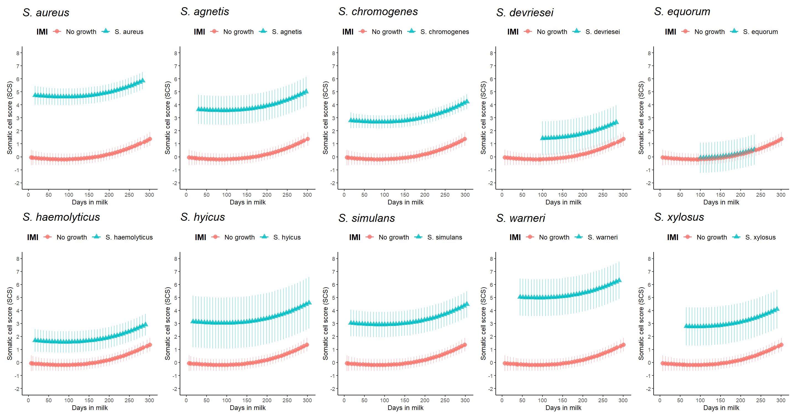

Figure XX. Quarter somatic cell score least square means estimates as a function of *Staph.* species IMI and days in milk, compared to culture negative quarters. Model estimates for each species are only presented for the range of days in milk found in the actual data set. Error bars represent the 95% confidence interval. [Is this true?]

Maybe don’t need legend with counts, if that’s in other table

Is this redundant in a way with the combined plot?

